Civil war in Liberia

UNSC Resolution: | 1478
Date of adoption: | 6-May-2003
Operative paragraph: | 13
Demand number: | 1478,1311

Sarah-Myriam Martin-Brûlé

Wording of demand
- establish an effective Certificate of Origin regime for Liberian rough diamonds that is transparent, internationally verifiable and fully compatible with the Kimberley Process, and provide the Committee with a detailed description of the proposed regime

List of addressees of the demand

Government of Liberia

Short-term compliance

Description of the addressee(s)’ conduct

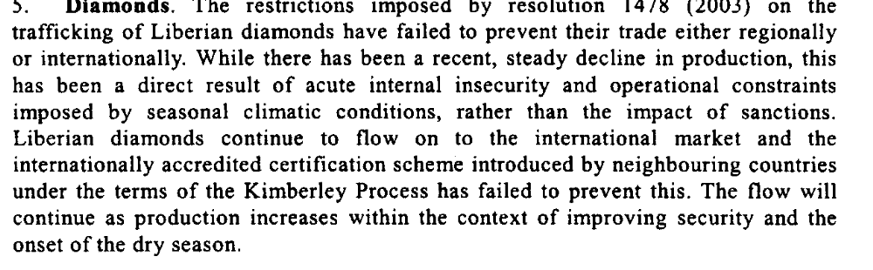



Assessment

Short-term compliance
X No or marginal compliance (1) | Medium low compliance (2) | Medium high compliance (3) | Full or almost full compliance (4)

Considerations underlying the assessment

Within the six months following the adoption of the resolution, the Government of Liberia failed to establish an effective Certificate of Origin regime for Liberian rough diamonds that is transparent, internationally verifiable and fully compatible with the Kimberley Process, and provide the Committee with a detailed description of the proposed regime

Medium-term compliance

Description of the addressee(s)’ conduct
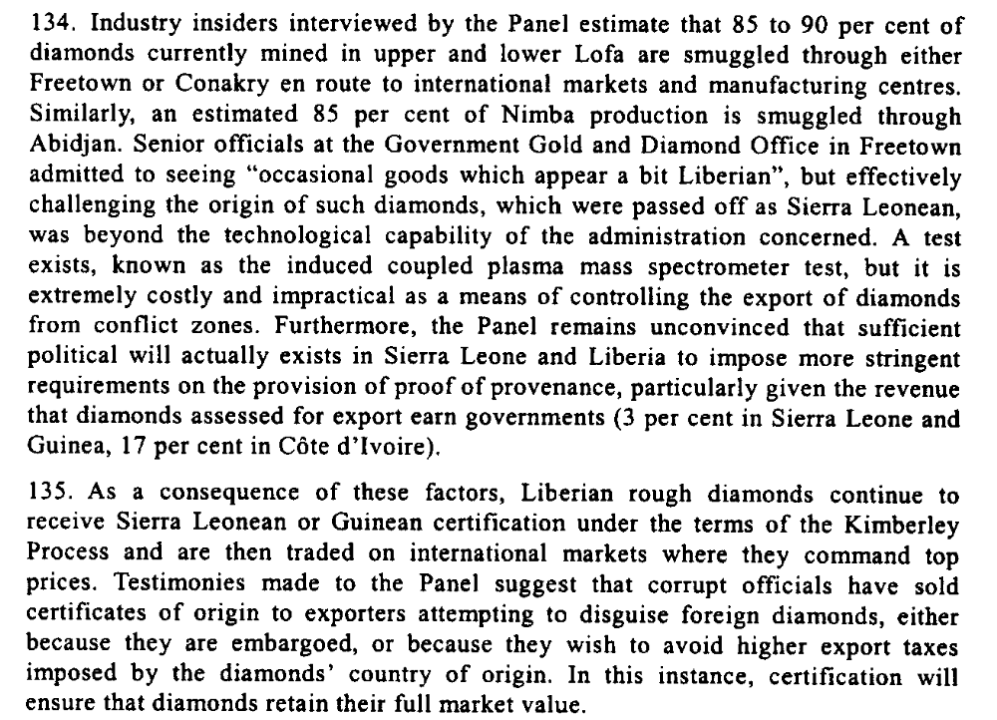

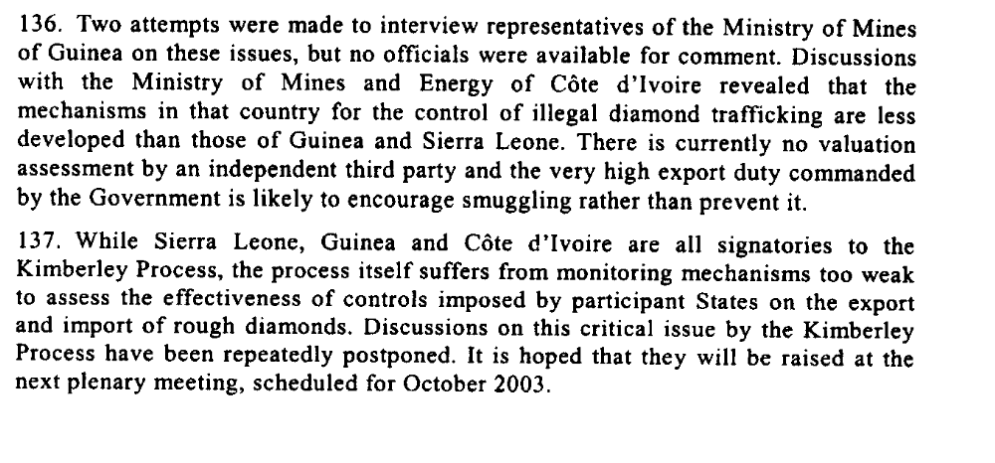

“Large numbers of ex-combatants continue to mine diamonds illegally, generating significant uncontrolled revenues and demonstrating the continued lack of control by the government over its territory, and thus raising security concerns. The Ministry of Lands and Mines has made insufficient progress in implementing the necessary controls for Liberia to join the Kimberley Process and for UN sanctions to be lifted.”

Global Witness Report. 2006. “Cautiously Optimistic: The Case for Maintaining Sanctions in Liberia”. 1 June.
http://www.globalwitness.org/media_library_detail.php/142/en/cautiously_optimistic_the_case_for_maintaining_san

Assessment

Medium-term compliance
No or marginal compliance (1) | X Medium low compliance (2) | Medium high compliance (3) | Full or almost full compliance (4)

Considerations underlying the assessment
Within the two years following the adoption of the resolution, the government of Liberia failed to establish an effective Certificate of Origin regime for Liberian rough diamonds that is transparent, internationally verifiable and fully compatible with the Kimberley Process, and provide the Committee with a detailed description of the proposed regime

Depth of demand

Assessment

Level of depth of demand
Low depth of demand (1) | X Medium depth of demand (2) | High depth of demand (3)

Considerations underlying the assessment
Given the significant source of revenues derived from the illicit trafficking of diamonds, compliance with this demand makes it more difficult for the demand addressees to win power.

Level of confidence about coding decisions

Level of confidence about coding decision
Extremely high | X High | Moderate

Comments to IPI (if any)

